

**Project Report**

**COURSE PROJECT SPRING 2024**

Course Title: Artificial Intelligence

Course Instructor: Shafique ur Rehman

**PROJECT TITLE**

**SIGN LANGUAGE DETECTION USING ASL SIGN LETTERS**

**PROJECT CONTRIBUTORS**

**FIZZA RASHID**

**NABEEHA MAQSOOD**

**ALISHBA KHAN**

**SUBMITTED TO**

**SIR SHAFIQUE UR REHMAN**

Table of Content

**Introduction (Aim or Motivation) 4**

**Background (Research & Project Selection) 4**

**Project Specification 4**

**Problem Analysis 4**

**Solution Design (Project Detail, Functionality and features) 5**

**Implementation & Testing 6**

**Project Breakdown Structure (Workload distribution with timeline) 6**

**Results (Outputs screenshots) 6**

**Conclusion (Summary & Discussion) 6**

## 

## 

## 

## 

## 

## Introduction (Aim or Motivation)

The aim of developing ASL language detection systems is to recognize and translate American sign language (ASL) into understandable text format. The motivation behind this project is to help and accommodate individuals who are deaf or hard of hearing to communicate more effectively with people who either do not understand/use ASL language or have the least knowledge of it. This system might be helpful and effective in various fields such as education, health care, and customer service, to improve accessibility and inclusivity.

## Background (Research & Project Selection)

Sign language refers to the manual language that uses hand gestures such as movement, different shapes etc. ASL is the most commonly used sign language in the United States of America. Due to lack of resources and technology to support ASL communication, it has been a great challenge for deaf or hard of hearing individuals to interact and communicate with people effectively. Therefore, we have chosen this project to take an initiative and implement the idea of ASL sign language detection using advanced technology.

## Project Specification

This proposed project includes a machine learning model that recognizes ASL sign language from camera inputs and translates them into respective letters. The system will use the camera to capture people performing ASL sign language. The captured image will be preprocessed to extract its features, such as hand gestures. These features will be then fed into the trained ml model to recognize ASL signs and translate them into corresponding letters.

## 

## Problem Analysis

Developing a sign language detection system is a challenging problem due to several factors. First, there is a high degree of variability in how individuals perform ASL signs, making it difficult to develop a one-size-fits-all solution. Second, the system must be able to handle different lighting conditions, backgrounds, and camera angles. Third, the system must be able to recognize signs quickly and accurately to be useful in real-world applications.

To address these challenges, the project will use a combination of machine learning techniques, such as deep learning and computer vision, to develop a robust and accurate sign language detection system.

Additionally, the project will collect and label a large dataset of ASL signs to train the machine learning model. The dataset will include various lighting conditions, backgrounds, and camera angles to ensure that the system can handle real-world scenarios.

## Solution Design (Project Detail, Functionality and features)

Project Details:

We have tried feeding multiple datasets to the train ml model. However, the dataset we have used is not enough for training purposes as it possesses data with less variation, lighting effects, same background and so on.

ASL Sign Language Chart:

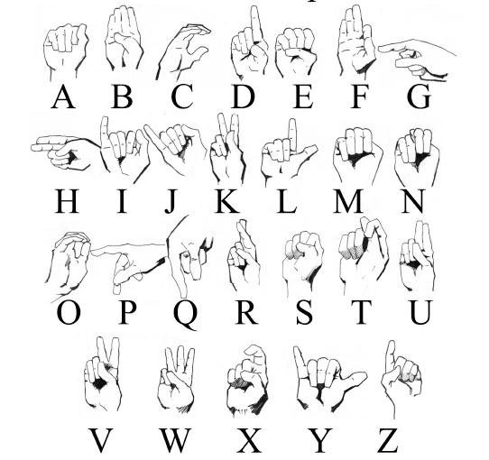

Functionality:

* *Video Input:* The system will accept video inputs from a camera or pre-recorded videos.
* Preprocessing: The video input will be preprocessed to extract features such as hand shape, movement, and location.
* *Sign Recognition:* The extracted features will be fed into a machine learning model that has been trained to recognize ASL signs. The model will output the recognized sign and its corresponding spoken language translation.
* *Real-time Recognition:* The system will be capable of recognizing signs in real-time, making it useful for live communication.

Features:

* *Speed:* The system will be capable of recognizing signs quickly, making it useful for real-time communication.
* *Customizability:* The system will allow users to customize the vocabulary of signs that the system can recognize.
* *User-friendly Interface:* The system will have a user-friendly interface that is easy to use and navigate.

## Implementation & Testing

1. We have used sample data available from github for training the model.

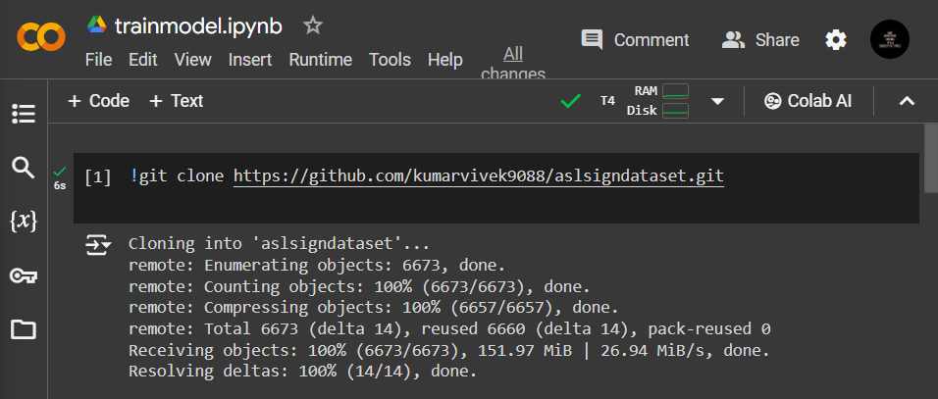

1. Importing required libraries.

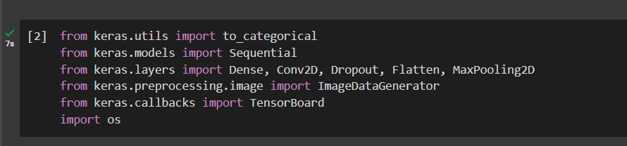

1. Generating image data of size 48x48.

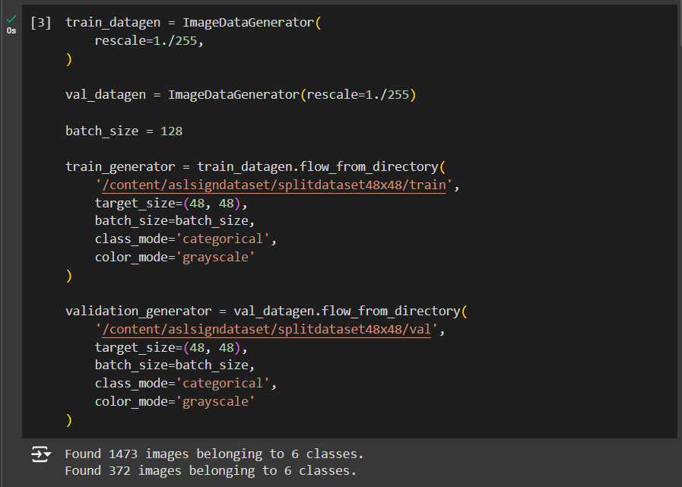

1. We have trained our model for ASL signs of A, M, N, S, T, and blank background.

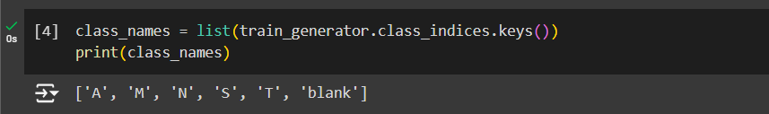

1. Applying convolutional layers.

(*What are Convolutional layers?* Convolutional layers are a type of neural network layer commonly used in computer vision tasks, such as image classification, object detection, and semantic segmentation. During training, convolutional layers perform a set of mathematical operations on the input data to extract features and patterns that are useful for the task at hand.

*What do convolutional layers do?* The main function of convolutional layers is to apply a set of filters or kernels to the input data. These filters are small matrices that slide over the input data, performing a convolution operation that combines the values of the input data within the filter's receptive field. The result of this operation is a feature map that highlights the presence of specific features in the input data.)

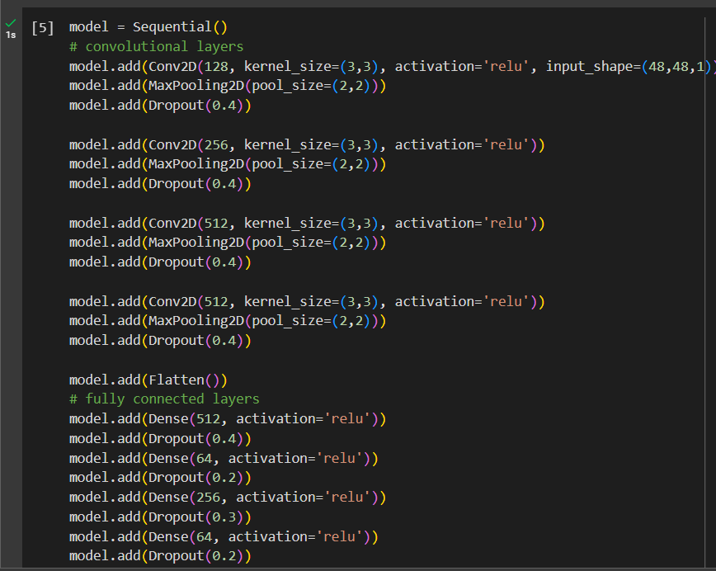

1. Model summary.

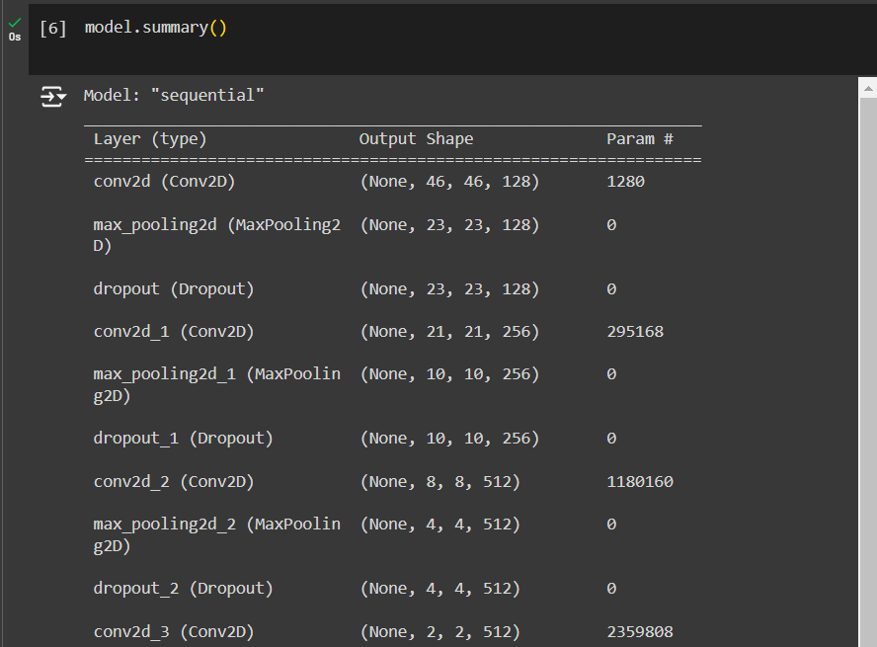

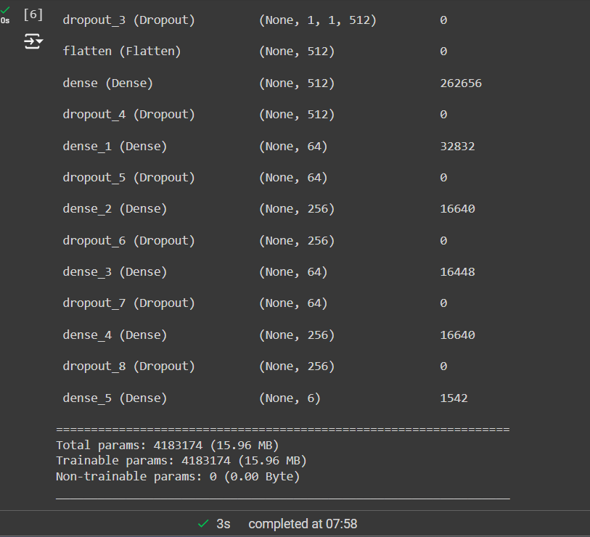

1. Compiling our Model.

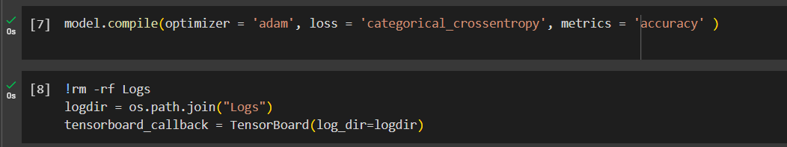

1. Finally, Training our model on the given sample.

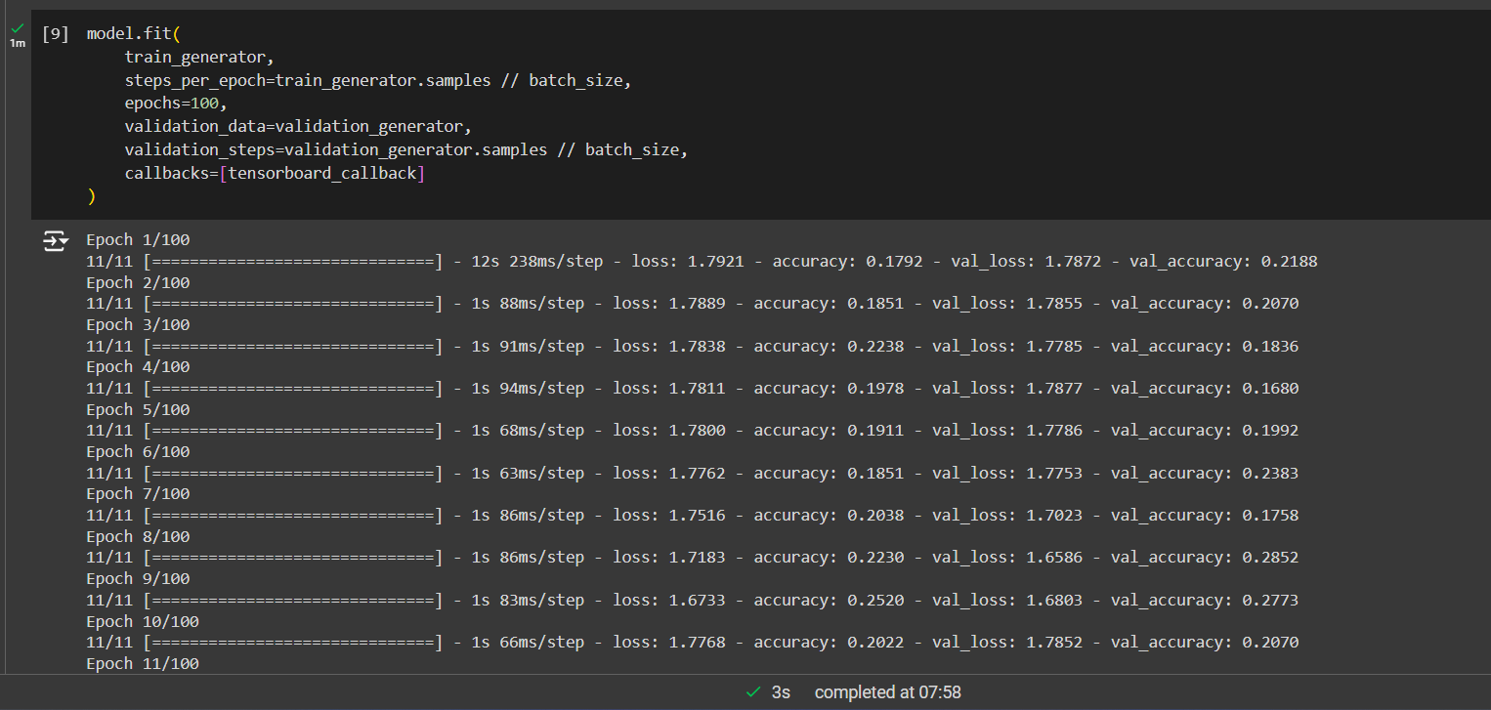

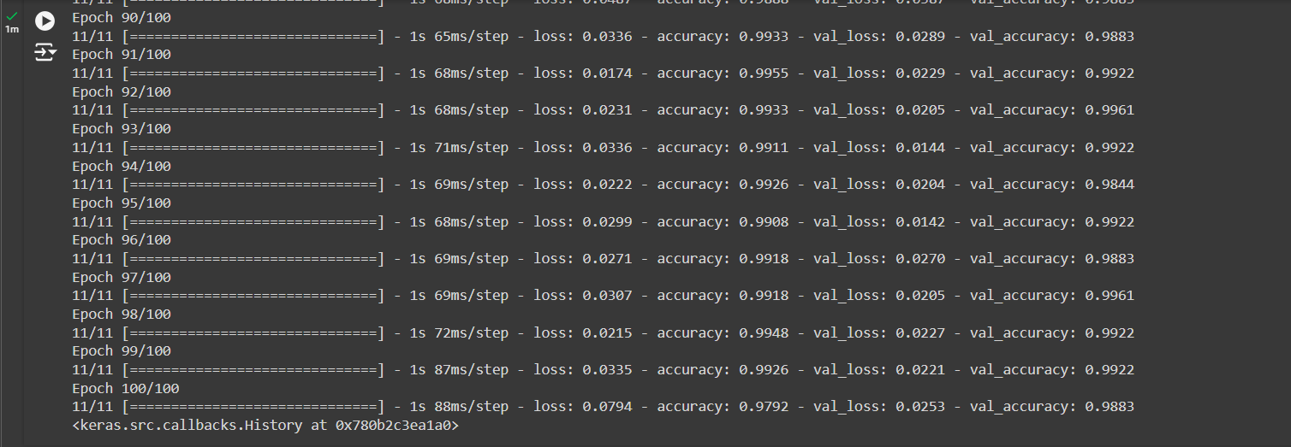

1. Tensorboard Visualization

(*What is a TensorBoard?* TensorBoard is a visualization tool for monitoring and understanding machine learning models during training. It allows users to visualize various aspects of the training process, such as the model's architecture, training metrics, and data distributions. Some key features of TensorBoard are graphs, time series, image, histogram and scalars)

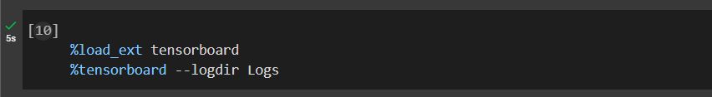

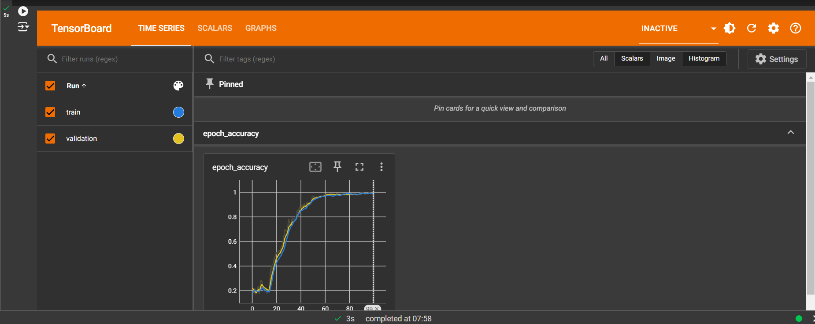

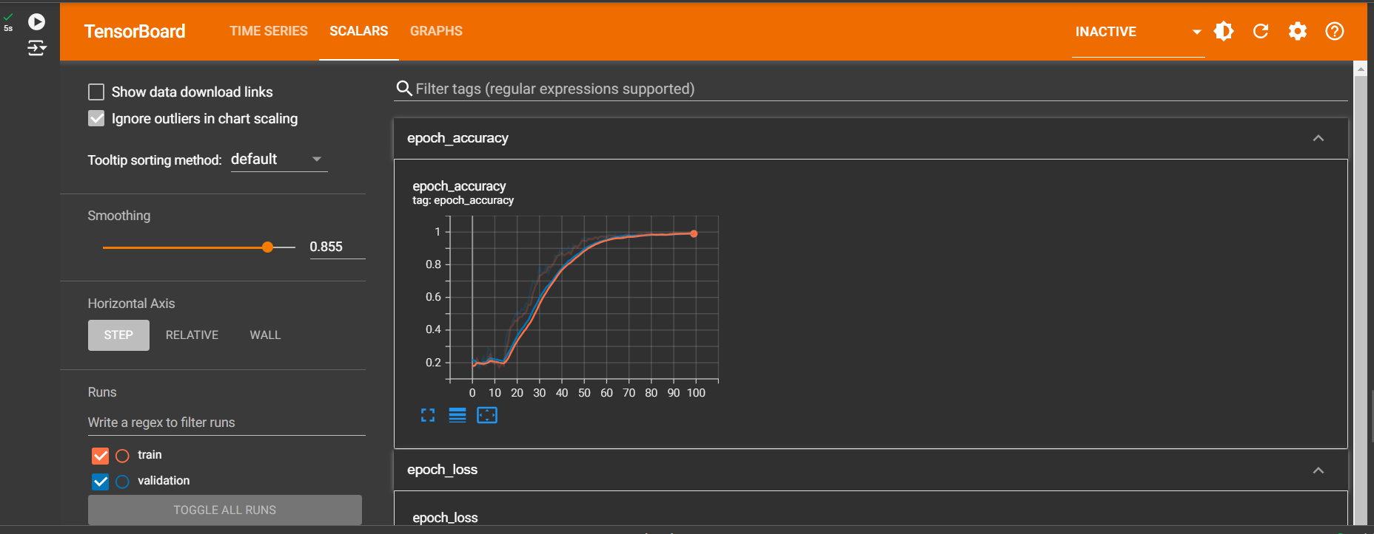

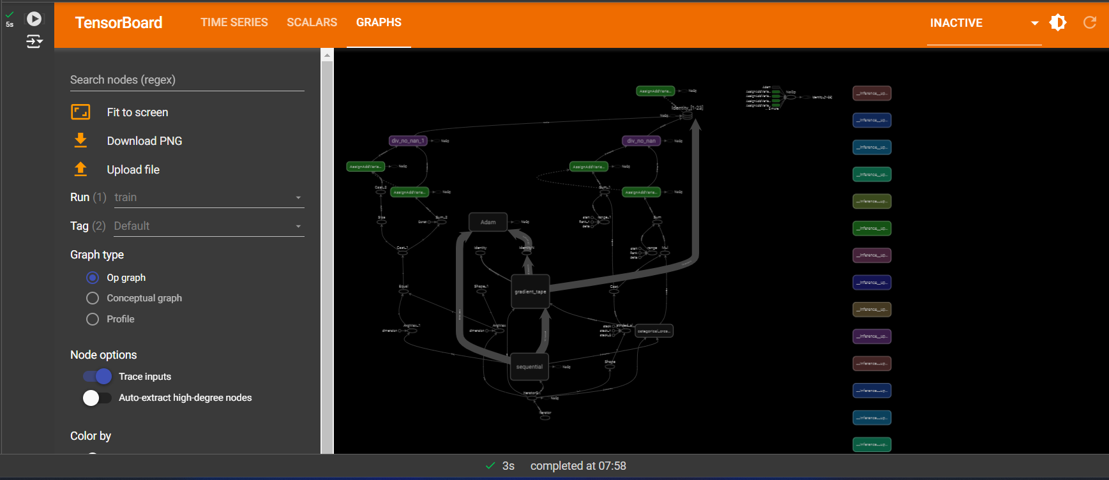

Train Graph:

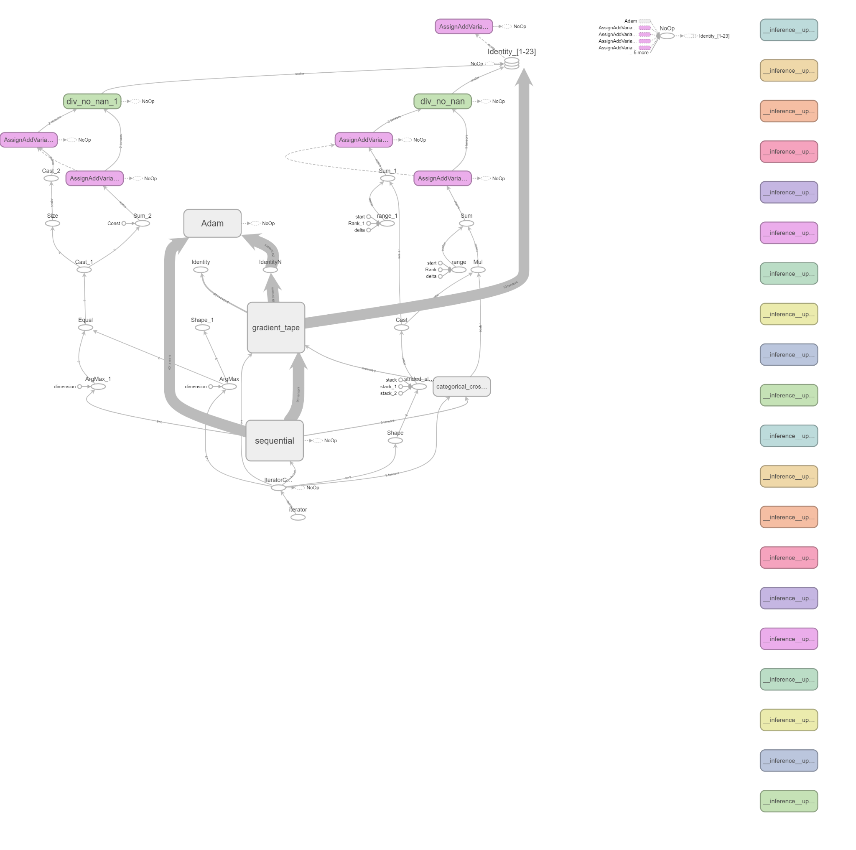

1. In the end, we saved the project in our drive.

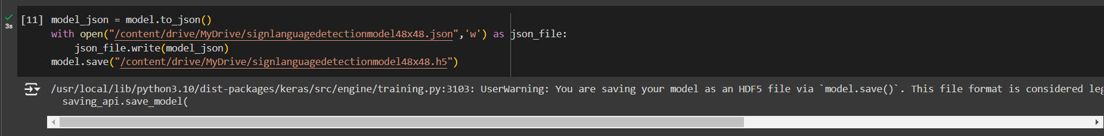

## Project Breakdown Structure (Workload distribution with timeline)

Entire project i.e each and every component of the project has been developed with the mutual decisions of all 3 group members. We worked on a single device to integrate and train our model in order to prevent any misunderstandings. All group members participated actively throughout the project development i.e from selecting the project idea till the final deployment of the idea.

## Results (Outputs screenshots)

Real Time Sign Language Detection Testing:

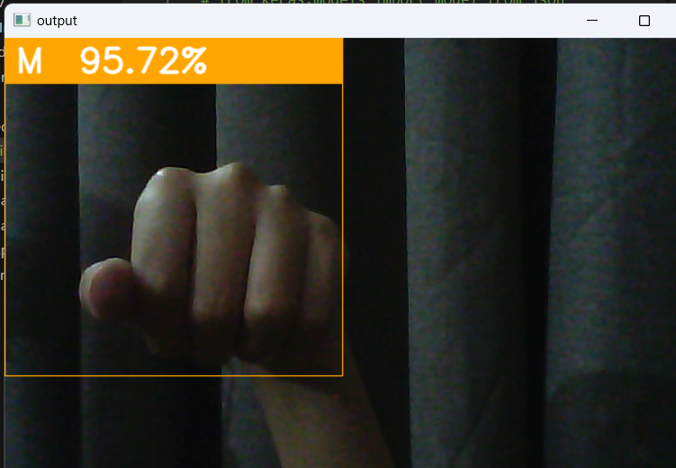

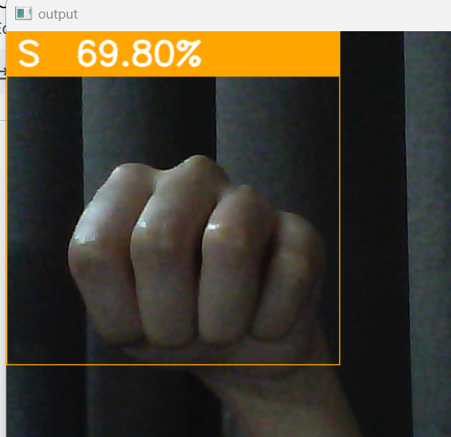

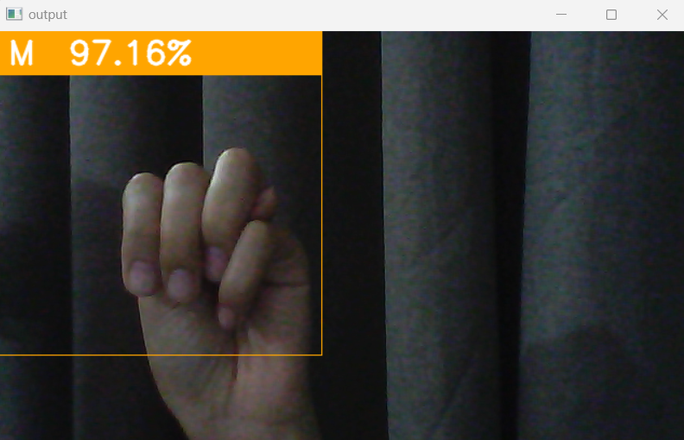

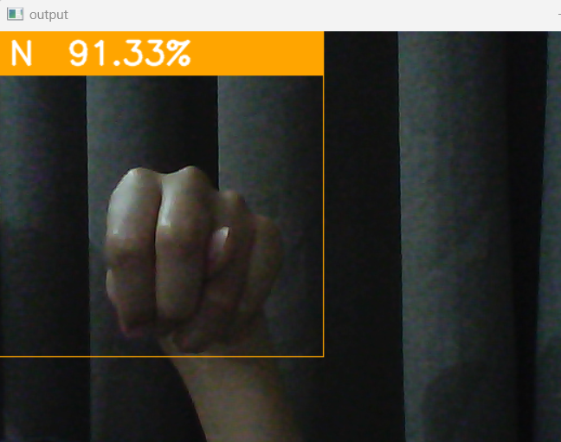

## Conclusion (Summary & Discussion)

In summary, the ASL sign language detector project is an exciting and impactful initiative that can improve the lives of millions of people worldwide. The project's success will depend on the collaboration between experts in various fields, the availability of high-quality training data, and the development of accurate and user-friendly machine learning models.